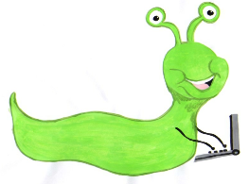

Lyng Primary School Knowledge Organiser

Information Technology



Spring 2

Computer art

Year 2

Topic: IT

|  |  |
| --- | --- |
| What Goldilocks and Step On words will I use? | |
| **Spelling** | **Defintion** |
| Impressionism | The impressionist movement began in the 1860s and became most popular in 1870s and 1880s. It would capture a scene at a moment. The art gave an ‘impression’ of the time |
| Palette | Within computer graphics, this is the range of colours or shapes availabel to the user. |
| Pointillism | Pointillism was a development of impressionism. It was invented mainly by George Seurat and Paul Signac. Pointillist paintings are created by using small dots in different colours to build up the whole picture. Colours are placed near each other rather than mixed. |
| Surrealism | Explored the subconscious areas of the mind. The artwork often made little sense as it was usually trying to depict a dream or random thoughts. |
| Template | Something that serves as a model for others to copy. |
|  |  |

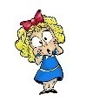

**Aims of this unit**

* To use technology purposefully to create, organise, store, manipulate and retrieve digital content.
* To create computer art by:
* Using a range of tools in a computer program.
* Making and editing shapes
* Changing the shade of a colour for effect.
* Retrieving a file to edit in a computer.

**Safeguarding**

Filtering and monitoring system is in place. Children will use their own log in details to track any misuse and to protect the child from harmful websites and pop ups. Children will be reminded of how to stay safe online and to use technology safely and respectfully and to tell a trusted adult if there is anything on their computer that makes them uncomfortable.

|  |
| --- |
| Outcomes |
| **All children**   * Access an appropriate program for achieving a specific task * Switch between program tools to produce different techniques * Alter the formatting of a tool to adjust the colour or size   **Most children**   * Recreate a piece of art using a computer program. * Manipulate shapes and objects to recreate an art style.   **Some children**   * Select appropriate tools with confidence and independence. |

Spring term 2

Computer art

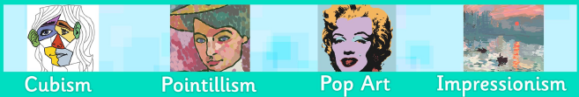

**In this unit…**

Children will learn how to reproduce the painting styles of great artists using computer programs. Each lesson will focus on a different artist and their particular style. The children will use this as inspiration for mastering specific techniques within design-based software.

**Agreed outcome:**

Create a picture linked to the Black Country.