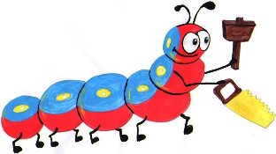

Lyng Primary School Knowledge Organiser

Design Technology

**Australia - How can I join materials together?**

Year 2

Topic: DT

Autumn

|  |  |
| --- | --- |
| What Goldilocks and Step On words will I use? | |
| **Spelling** | **Defintion** |
| Fabric | Fabric is cloth or other material produced by weaving together [cotton](https://www.collinsdictionary.com/dictionary/english/cotton), [nylon](https://www.collinsdictionary.com/dictionary/english/nylon), [wool](https://www.collinsdictionary.com/dictionary/english/wool), [silk](https://www.collinsdictionary.com/dictionary/english/silk), or other [threads](https://www.collinsdictionary.com/dictionary/english/thread). |
| Design | to generate, develop and communicate ideas for a product. |
| Embroider | to decorate fabric with stitches |
| Sew | to join pieces of fabric with stitches. |
| Seam | a row of stitches joining two pieces of fabric. |
| Appliqué | to attach a decorative fabric item onto another piece of fabric by gluing and/or sewing. |
| Template | a shape drawn to assist in cutting out shapes |
| Evaluate | to judge how a product meets chosen criteria |



**Design Brief for pupils:**

* Create a snowman puppet
* Use a simple stitch
* Use joining techniques such as stitching, gluing and stapling.

**Purpose:** to design a snowman puppet to accompany their story from English.

**Audience:** our parents to engage and entertain.



|  |
| --- |
| Skills and techniques |
| * Explore and evaluate a range of existing textile products. * Explore different joining techniques in textiles such as stitching, gluing and stapling. * Select appropriate tools and equipment to perform practical tasks such as marking out, cutting, joining and finishing. * Experiment with different finishing techniques e.g. using painting, fabric crayons, stitching, sequins, buttons and ribbons.   **Agreed outcome:**  A snowman puppet. |

Autumn Term

**Textiles**

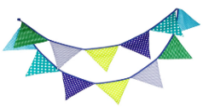

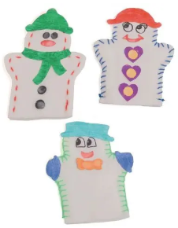

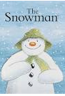

**Finishing Techniques:**

**Joining Techniques:**

