|  |  |  |
| --- | --- | --- |
| **Lyng Primary School P.E Knowledge Organiser** | | |
| **Topic: Tennis** | Year 5 | Summer 1 |

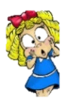



|  |  |
| --- | --- |
| **Key words** | |
| **Spelling** | **Definition** |
| Drop Shot | A technique used to make the ball get over the net and remain close to the net. |
| Rally | When a ball is hit back n forth between yourself and an opponent. |
| Forehand | Type of tennis stroke, racket in strongest hand sideways on. |
| Volley | A volley shot hitting the ball without bouncing. |
| Stroke | Different types of strokes, where you are hitting the ball back at an opponent. |
| Slice | A shot type using a different technique to make it more difficult for the opponent to return. |
| Doubles | 2 players vs 2 players |

**Enquiry Questions**

* Can you keep the ball up on your racket more than 10 times?
* Can you perform a rally using only a forehand shot?
* Can you perform a controlled volley shot?
* What is a backhand slice?
* When serving, how & where on the court should you serve?
* Can we transfer the various shots practiced into a game situation?

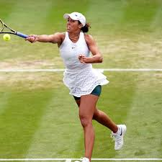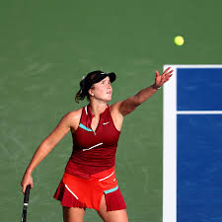

***“Attitude determines altitude”***

**– Mav Levy**

|  |  |  |
| --- | --- | --- |
| **Lyng Primary School P.E Knowledge Organiser** | | |
| **Topic: Tennis** | Year 5 | Summer 1 |

Learning Outcomes

* To develop various ball skills from both standing and on the move.
* To be able to perform a forehand shot in a rally.
* To develop a volley shot with accuracy from various positions on the court.
* To develop a backhand shot and to practice the backhand slice
* To be able to consistently hit the service box when serving.
* To develop shot accuracy when playing a match against an opponent & identify areas on the court to score points.

