|  |  |  |
| --- | --- | --- |
| **Lyng Primary School P.E Knowledge Organiser** | | |
| **Topic: Basketball** | Year 5 | Autumn 2 |

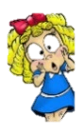



**Enquiry Questions**

* What are the different ways of moving with the ball amongst your team?
* What is a double dribble? & What is travelling?
* What are the different types of passes?
* Where on the pitch can you get 3 points from scoring a basket?
* In a 2v1 situation against you, when is the best time to commit to the tackle?
* Can we transfer skills into a game situation?

|  |  |
| --- | --- |
| **Key words** | |
| **Spelling** | **Definition** |
| Possession | Having possession of the ball is when your team has control of the ball |
| 3 pointer | Scoring from a certain area on a court worth 3 points. |
| Slam dunk | Slam dunk is a type of shot, where a player is air bound and makes the shot by slamming the ball through the hoop. |
| Free throw | Free throw is when a free shot is taken from a position on the court, the opposition are not allowed to prevent you from taking the shot. |
| Press | When the opposition have the ball and us as the defending team puts them under immediate pressure. |
| Chest pass | A type of pass made in basketball, pushing the ball from chest to chest. |

***“Don’t be afraid of failure. This is the way to succeed”***

* **Lebron James**

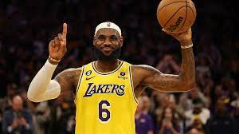 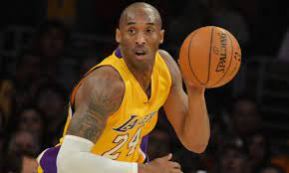

**– Mav Levy**

|  |  |  |
| --- | --- | --- |
| **Lyng Primary School P.E Knowledge Organiser** | | |
| **Topic: Basketball** | Year 5 | Autumn 2 |

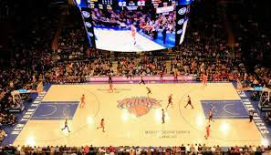

Learning Outcomes

* To practice change of direction when travelling at speed.
* To develop dribbling techniques.
* To improve different types of passes within basketball.
* To develop shooting with accuracy.
* To practice attacking and defending overloads i.e. 2v1 3v1 situations
* To put skills into game play.