|  |  |  |  |
| --- | --- | --- | --- |
| \\lyng-dc1\StaffShared\Learning Bugs Animals ALL subjects\characters bugs animals\Cyril the Snail - History.jpeg**Lyng Primary School Knowledge Organiser** | | | |
| **History Topic:** | **Australian Adventure**  Who are the British Royal family and what are their roles in Australia? | Year 2 | Autumn |

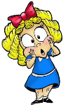

**Background information for parents and teachers**

Queen Elizabeth II, Queen of the United Kingdom of Great Britain and Northern Ireland, is the longest reigning British monarch in history. Elizabeth was born on 21 April 1926 and became queen on 6 February 1952. Her coronation took place in Westminster Abbey, on 2 June the following year. Queen Elizabeth II is also the Head of the Commonwealth, a group of 53 countries across the globe.

|  |  |
| --- | --- |
| **What Step On and Goldilocks words will I use?** | |
| **Spelling** | **Definition** |
| monarch: | the king or queen |
| coronation: | ceremony at which a king or queen is crowned |
| decade: | a period of time that lasts ten years |
| government: | people who run a country |
| political: | how power is used in a country |
| tradition: | a custom that has existed for a long time |
| Commonwealth: | a group of countries who are friendly towards each other and have something in common. |
| Aboriginal: | a member of a race of people who were the first people to live in a country, before any colonists arrived |

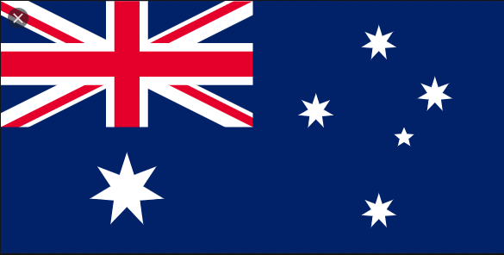

|  |  |
| --- | --- |
| **When? (Timeline of key events)** | |
| 1926: | Born |
| 1947: | Married Prince Philip |
| 1952: | Became queen |
| 1953: | Coronation at Westminster Abbey |
| 2012: | Celebrated her diamond jubilee |
| 2015: | Became the longest reigning monarch in Britain |
| 2022: | Celebrated her platinum jubilee |
| 2022: | Queen Elizabeth 2nd died |

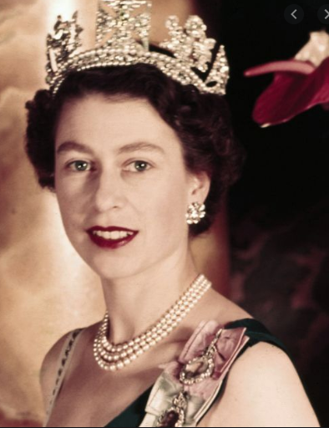

**TRIP/VISITOR**

Trip to Dudley zoo.

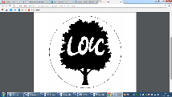

**Queen Elizabeth** – "I have in sincerity pledged myself to your service, as so many of you are pledged to mine..”

**Great Quotes**

**Hook (LOtC)**

Australian Bush Tucker trail.

**Our Storytelling Approach to enhance engagement**

**Focus Text**

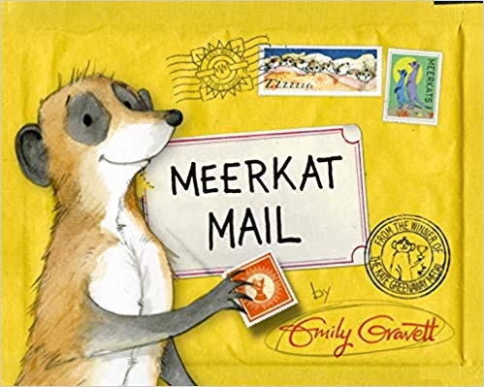

|  |  |  |
| --- | --- | --- |
| **People:**  The Aboriginal People | **Place:**  Australia | **Problem:**  British Empire |

**Key Facts and Famous Figures**

Queen Elizabeth II does not control the British government and is not involved in political decisions.

**Agreed Outcome**

* A fact-file on Queen Elizabeth
* A piece of work on the Commonwealth
* A comparison of royal family then and now.

Instead, the Queen travels all over Britain and around the world visiting charities, celebrations and

public events. The Queen also welcomes important visitors to Britain, including the leaders and rulers

of other countries. Queen Elizabeth II is also the Head of the Commonwealth, a group of 53 countries

across the globe. The Queen continues to follow royal tradition, including some started by Queen

Victoria. However, she has also tried to make the monarchy more modern during her time as queen.

She started giving her Christmas message on the television in 1957 and has tried to show the public a

more relaxed side of the royal family ever since. The Queen holds the title 'Defender of the Faith and

Supreme Governor of the Church of England'. This means she is the leader of the Church of England.

These titles date back to Henry VIII's time.

**Key skills – Taken from Milestone 1**

**Key Questions – sequence of learning**

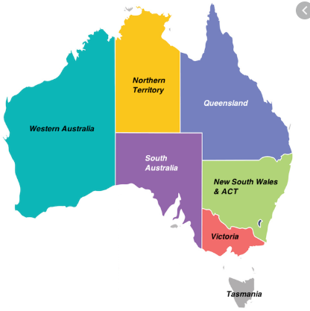

Who have been monarchs of the United Kingdom?

Who is in the Windsor family tree?

Who is Queen Elizabeth 2nd ?

Who is Mary Seacole?

What are aboriginal artefacts used for?

**Communicate historically**

* Show an understanding of the concept of nation

and a nation’s history.

* Show an understanding of concepts such as civilisation,

monarchy, parliament, democracy, and war and peace.

**Build an overview of world history an overview of**

* Describe significant people from the past.

**Understand chronology**

* Use dates where appropriate

|  |  |  |  |
| --- | --- | --- | --- |
| \\lyng-dc1\StaffShared\Learning Bugs Animals ALL subjects\characters bugs animals\Cyril the Snail - History.jpeg**Lyng Primary School Knowledge Quiz** | | | |
| **History Topic:** | **Australian Adventure** | Year 2  *Queen Elizabeth 2nd* | Autumn |

|  |  |  |
| --- | --- | --- |
| 6. What does monarch mean? | **S** | **E** |
| The king or queen |  |  |
| The Prime Minister |  |  |
| The President |  |  |

|  |  |  |
| --- | --- | --- |
| 7. How many children does the queen have? | **S** | **E** |
| 4 |  |  |
| 3 |  |  |
| 2 |  |  |

|  |  |  |
| --- | --- | --- |
| 1. Who are the aboriginal people ? | **S** | **E** |
| Native to America |  |  |
| Native to England |  |  |
| Indigineous people of Austrailia |  |  |

|  |  |  |
| --- | --- | --- |
| 1. What is a digeridoo? | **S** | **E** |
| An Australian person |  |  |
| An Australian animal |  |  |
| An Australian instrument |  |  |

|  |  |  |
| --- | --- | --- |
| 1. Who was the Queen married to? | **S** | **E** |
| Prince Edward |  |  |
| Duke of Edinburgh |  |  |
| Prince Charles |  |  |

|  |  |  |
| --- | --- | --- |
| 1. When was Queen Elizabeth born? | **S** | **E** |
| 21st of April 1926 |  |  |
| 21st of April 1966 |  |  |
| 21st of April 1946 |  |  |

**Our Australian Adventure**

**Quick Quiz**

|  |  |  |
| --- | --- | --- |
| 1. When did Queen Elizabeth become Queen? | **S** | **E** |
| 2nd June 1903 |  |  |
| 2nd June 2003 |  |  |
| 2nd June 1953 |  |  |

|  |  |  |
| --- | --- | --- |
| 1. Who is the longest reigning British monarch? | **S** | **E** |
| Queen Victoria |  |  |
| Queen Elizabeth 1st |  |  |
| Queen Elizabeth 2nd |  |  |

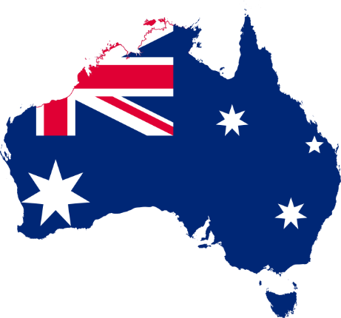

|  |  |  |
| --- | --- | --- |
| 1. What does commonwealth mean? | **S** | **E** |
| A group of countries who are friendly towards each other and have something in common. |  |  |
| A wealthy country. |  |  |
| People who have things in common. |  |  |

|  |  |  |
| --- | --- | --- |
| 1. What does coronation mean? | **S** | **E** |
| A T.V programme |  |  |
| A ceremony when the monach is crowned |  |  |
| A name of a country |  |  |