|  |  |  |  |
| --- | --- | --- | --- |
| **F:\Learning bugs\Foundation Subjects\Dolly the Fly - Science.jpgLyng Primary School Knowledge Organiser** | | | |
| **Topic:** | **Science**  **Classification and changing habitats** | Year 4 | Summer |

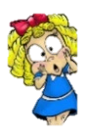

**Sir David Attenborough.**

“The truth is: the natural world is changing. And we are totally dependent on that world. It provides our food, water, and air. It is the most precious thing we have, and we need to defend it.”

**What should I already know?**

* All animals need water, air and food to survive.
* Animals get nutrition from what they eat.
* What carnivores, omnivores and herbivores are.
* Excretion is one of the seven living processes
* Animals can be grouped into carnivores, herbivores and omnivores and other ways in which to classify animals.
* The differences between the teeth of carnivores and herbivores.
* Some habitats and the animals and plants that can be found there.
* Examples of habitats (including microhabitats) and the animals and plants that can be found there.
* The names of some common wild and garden plants and deciduous and evergreen trees.
* Living things depend on each other to survive.
* How land use has changed over time and the effects this has on the environment (e.g. urban development)

|  |  |
| --- | --- |
| **What Step On and Goldilocks words will I use?** | |
| **Spelling** | **Definition** |
| Biome | A natural area of vegetation and animals |
| Carnivore | An animal that eats meat |
| Classification key | A system which divides things into groups or types |
| Coniferous | Evergreen trees/ trees that stay green all year |
| Deciduous | Trees that lose leaves in the autumn every year |
| Deforestation | The action of clearing a wide area of trees. |
| Eco-system | A biological community of interacting organisms and their physical environment. |
| Endangered | A species seriously at risk of extinction. |
| Energy | The ability and strength to do physical things |
| Environment | All the circumstances, people, things, and events around them that influence their life |
| Excretion | The process of eliminating waste from the body |
| Extinct | A species having no living members/ no longer in existence |
| Food chain | A series of living things which are linked to each other because each thing feeds on the one next to it in the series |
| Food web | A combination of food chains that integrate to form a network |
| Habitat | The natural environment in which an animals or plant normally lives or grows |
| Herbivore | An animal that only eats plants |
| Invertebrate | An animal without a backbone |
| Life processes | There are seven processes that tell us that living things are alive |
| Microhabitat | A small part of the environment that supports a habitat, such as a fallen log in a forest |
| Nutrition | The process of taking food into the body and absorbing the nutrients in those foods |
| Omnivore | Person/ animal eats all kinds of food, including both meat and plants |
| Organism | A living thing |
| Pollution | the presence in or introduction into the environment of a substance which has harmful or poisonous effects. |
| Predator | An animal that kills and eats other animals |
| Prey | An animal hunted or captured by another for food |
| Sensitivity | Responding to the external environment |
| Vegetation | Plants, trees and flowers |
| Vertebrate | Creature which has a spine |

|  |
| --- |
| **Investigate!** |
| * Understand what the 7 life processes are. * Complete Venn diagrams to show if living things can be grouped into two or more groups. * Use criteria to sort living things in a Carroll diagram. * Sort vertebrate and invertebrate animals into groups, describing their key features. * Understand and use a classification key to identify which group of vertebrates an animal belongs to and then create your own. * Sort plants/ trees into groups (e.g. flowering plants and non-flowering plants) and then create a classification key to help others identify plants. * Identify different trees and what type of forest they live in. * Carefully observe minibeasts in a microhabitat and use a classification key to identify them. * Use simple computer software programmes to create a branching classification key. * Explore examples of human impact (both positive and negative) on environments. * Present a discussion about deforestation and the impact of this. * Create an eco-leaflet about pollution, litter, and the impact of this on the planet and living things. |

|  |
| --- |
| **Enquiry Questions** |
| * How do you group animals in various ways? * Why do we group plants in various ways? * Why do you need to make observations when classifying? * How do you recognise different habitats and their inhabitants? * What is the impact humans have on the habitats? * What does the impact of natural disaster have on habitats? |

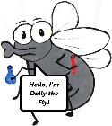

**What will I know by the end of the unit?**

|  |  |
| --- | --- |
| How can living things be grouped? | * All living things, which can also be called organisms, have to do certain things to stay alive. * These are the life processes: Movement Respiration Sensitivity Growth Reproduction Excretion Nutrition * Living things can be grouped according to different criteria (where they live, what type of organism they are, what features they have). For example, a camel can belong in a group of vertebrates, a group of animals that live in the desert, and a group of animals that have four legs. * How to use a Venn Diagram and Carroll Diagram. * How to understand a Classification key. |
| What is a classification key? | * A classification key is a tool that is used to group living things to help us identify them. |
| How can environments change? | * Habitats can change throughout the year and this can influence the plants and animals that live there. * Humans can have positive and negative effects on the environment:   - positive effects: nature reserves, ecological parks  - negative effects: litter, urban development.   * Deforestation can cause animals to lose their homes and habitats. * Pollution impact the environment negatively. |

|  |  |  |  |
| --- | --- | --- | --- |
| **F:\Learning bugs\Foundation Subjects\Dolly the Fly - Science.jpgLyng Primary School Knowledge Organiser** | | | |
| **Topic:** | **Science** **Classification and changing habitats** | Year 4 | Summer |

|  |  |  |
| --- | --- | --- |
| 1. What type of animal is a bat? | **S** | **E** |
| a) Mammal |  |  |
| b) Bird |  |  |
| c) Insect |  |  |

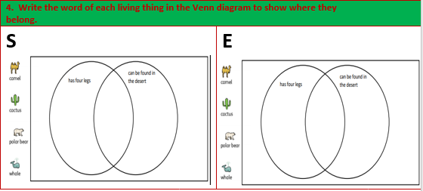

|  |  |
| --- | --- |
| 2. What are the 7 life processes? |  |
| **S** | **E** |
|  |  |
|  |  |
|  |  |
|  |  |
|  |  |
|  |  |
|  |  |

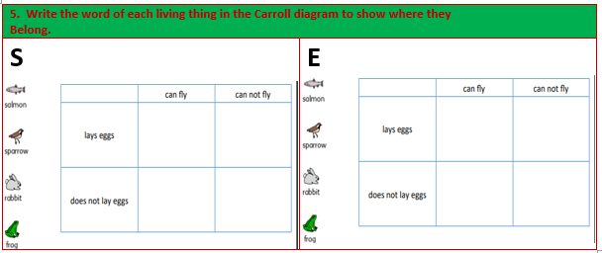

|  |  |
| --- | --- |
| 3. List 3 ways we can help the local | environment? |
| **S** | **E** |
|  |  |
|  |  |
|  |  |