|  |  |  |  |
| --- | --- | --- | --- |
| \\lyng-dc1\StaffShared\Learning Bugs Animals ALL subjects\characters bugs animals\Cyril the Snail - History.jpeg**Lyng Primary School Knowledge Organiser** | | | |
| **History Topic:** | **WWII** | Year 4  *Battles, Beliefs and Buildings* | Summer |

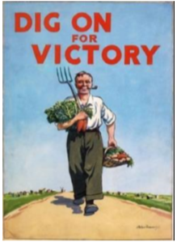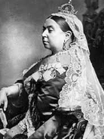

|  |  |
| --- | --- |
| **What Step On and Goldilocks words will I use?** | |
| **Spelling** | **Definition** |
| air raid | An attack by planes dropping bombs |
| air raid shelter | A building to protect people from bombs |
| Allies | Countries (including Britain, France, the Soviet Union and the USA) who joined forces to fight the Axis Powers. |
| allotment | Small plot of land for growing vegetables |
| Axis Power | Germany, Japan, Italy and other countries that were allies in World War 2. |
| Blackout | Wartime ban on street lights and other lights at night. |
| Blitz | German air raids, from a German word 'blitzkrieg' which means 'lightning war'. |
| British Empire | Countries rules by Britain |
| Concentration camp | Prison where Jews and other prisoners were kept by the Nazis. |
| British Empire | Lands that Britain controlled all over the world (for example, India). |
| Evacuee | Someone who was evacuated, moved from a danger area to a safer place. |
| Factory | Places where things are made |
| Forces | The Army, Royal Air Force, Royal Navy and other services. |
| Gas mask | Face mask to protect people against poison gas. |
| Holocaust | Mass murder of Jews and other people by the Nazis. |
| Host family | People who took evacuees in. |
| Invaded | Attacked or taken over by an enemy. |
| Jews | People who follow the religion of Judaism. |
| Nazi | Short for National Socialist Party (in Germany), a follower of Hitler was also called a Nazi. |
| Occupied | Taken over by enemy forces. |
| Prime Minister | Leader of the government of Britain. |
| Propaganda | Controlling news media (such as radio) to show your side in the best ways |
| Rationing | Controlling the supply of food, clothes, petrol and other things. |
| Refugee | A person forced to leave their home, often by war. |

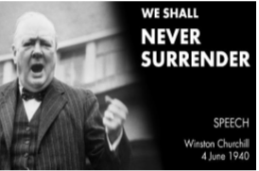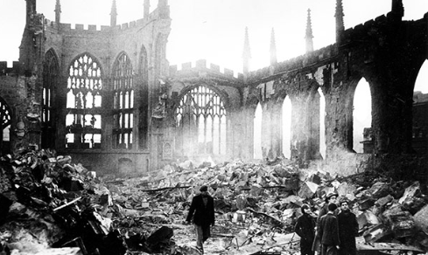

For almost six years from 1939 to 1945 Britain fought the toughest war it had ever experienced. World War II was total war- every person, every business, every service was involved. Britain did not fight alone; the war was also involved many countries. World War II involved 61 countries with 1.7 billion people (three quarters of the world’s population). Fifty million people lost their lives and hundreds of millions of people were injured.

|  |  |
| --- | --- |
| **When? (Timeline of key events)** | |
| 30th January 1933 | Adolf Hitler becomes Chancellor of Germany. His Nazi Party, or the Third Reich, takes power and Hitler is essentially the dictator of Germany. |
| 1st 1939 September | Germany invades Poland. World War II begins |
| 3rd Sep 1939 | France and Great Britain declare war on Germany. |
| 10th May to 22nd June 1940 | Germany uses quick strikes called blitzkrieg, meaning lightning war, to take over much of western Europe including the Netherlands, Belgium, and northern France. |
| 30th May 1940 | Winston Churchill becomes leader of the British government |
| 20th July 1940 | Germany launches an air attack on Great Britain. These attacks last until the end of October and are known as the Battle of Britain |
| 7th Dec 1941 | The Japanese attack the US Navy in Pearl Harbor. The next day the US enters World War II on the side of the Allies |
| 6th June 1944 | 1944 June 6 - D-day and the Normandy invasion. Allied forces invade France and push back the Germans. |
| 30th Apr 1945 | Adolf Hitler commits suicide as he knows Germany has lost the war. |
| 7th May 1945 | Germany surrenders to the Allies. |
| 8th May 1945 | Winston Churchill announces VE Day - Victory in Europe. British people wave flags, sing and dance in the streets. WW2 ends in Europe |
| 6th and 9th Aug 1945 | The US drop two Atomic Bombs on Japan. |
| 14 Aug. 1945. | Japan surrendered to the Allies. |



**Hook**

**Let’s Say**

Create our own 1939 High Street and watch as it is bombed during Blitzkrieg



**TRIP/ VISITOR**  
**Coventry Cathedral-** A tour and talk of the destroyed cathedral bombed during WW2.

**Our Storytelling Approach to enhance engagement**

|  |  |  |
| --- | --- | --- |
| **People:**  Evacuees during WW2 | **Place:**  Coventry, Birmingham | **Problem:**  Our home has just been destroyed by German bombers |

**Focus Text**

**Key Facts and Famous Figures**

**Adolf Hitler (1929-1945)-** After World War One ended in 1918, Germany had to give up land and was banned from having armed forces. In 1933, the German people voted for a leader named Adolf Hitler, who led a political party in Germany called the National Socialists or Nazis. Hitler promised to make his country great again and quickly began to arm Germany again and to seize land from other countries**.**

**Anne Frank (1929-1945)-** A German Jewish girl who spent two years hiding from the Nazis in a house in Holland. Her wartime diary was published after the war.

**Neville Chamberlain (1940- 1969)**- was the British prime minister as Great Britain entered World War II. He is known for his policy of "appeasement" toward Adolf Hitler's Nazi Germany.

**Winston Churchill (1874- 1965)-** As prime minister (1940–1945) during most of World War II, Winston Churchill rallied the British people and led the country from the brink of defeat to victory. He shaped Allied strategy in the war.

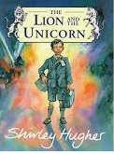



**Key skills – Taken from Milestone 2 – Sequence of Learning**

* I can use evidence to ask questions and find answers about the past.
* Use more than one source of evidence for historical enquiry in order to gain a more accurate understanding of history.
* I can describe the characteristic features of the past, including ideas, beliefs, attitudes and experiences of men, women and children.
* I can use dates and terms to describe events.
* I can use appropriate historical vocabulary to communicate
* I can use literacy, numeracy and computing skills to a good standard in order to communicate information about the past.

**Agreed Outcome**

To understand the cause and effects of WW2.

|  |  |  |  |
| --- | --- | --- | --- |
| \\lyng-dc1\StaffShared\Learning Bugs Animals ALL subjects\characters bugs animals\Cyril the Snail - History.jpeg**Lyng Primary School Knowledge Organiser** | | | |
| **Topic:** | **WWII** | Year 4  *Battles, Beliefs and Buildings* | Summer |

|  |  |  |
| --- | --- | --- |
| 6. Who was Adolf Hitler? | **S** | **E** |
| 1. The King of Germany |  |  |
| 1. The leader of the Nazi party |  |  |

|  |  |  |
| --- | --- | --- |
| 7. Where did people go during an air raid? | **S** | **E** |
| 1. Supermarket |  |  |
| 1. School |  |  |
| 1. Shelter |  |  |

|  |  |  |
| --- | --- | --- |
| 8. What is an evacuee? | **S** | **E** |
| _______________________________ _______________________________ |  |  |

|  |  |  |
| --- | --- | --- |
| 9. What 3 countries formed the Axis power? | **S** | **E** |
| 1. |  |  |
| 2. |  |  |
| 3. |  |  |

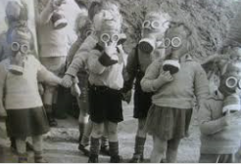

|  |  |  |
| --- | --- | --- |
| 1. When did WW2 begin? | **S** | **E** |
| 1. 1914 |  |  |
| 1. 1939 |  |  |
| 1. 1945 |  |  |

|  |  |  |
| --- | --- | --- |
| 2. Who was the Prime minister in Britain during most of WW2? | **S** | **E** |
| a) Winston Churchill |  |  |
| b) Adolf Hitler |  |  |
| C) Franklin Roosevelt |  |  |

|  |  |  |
| --- | --- | --- |
| 3. What is the Blitz? | **S** | **E** |
| ________________________________ ________________________________ |  |  |

|  |  |  |
| --- | --- | --- |
| 4. What year did WW2 end? | **S** | **E** |
| a) 1919 |  |  |
| b) 1939 |  |  |
| c) 1945 |  |  |

|  |  |  |
| --- | --- | --- |
| 5. Name allies that England had during WW2? | **S** | **E** |
|  |  |  |
|  |  |  |