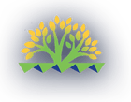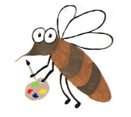

Lyng Primary School Knowledge Organiser

Art

Year 3

Topic: Art

Autumn and

|  |  |
| --- | --- |
| Vocabulary | |
| **Spelling** | **definition** |
| **art critic** | *Someone who studies and comments on art work.* |
| **charcoal** | *Charcoal is a black substance obtained by burning willow wood in a kiln. Small sticks of it are used for drawing.* |
| **Prehistoric** | *History before recorded history.* |
| **Pigment** | *Something that is added to something else to give it colour* |
| **Natural pigment** | *A pigment that occurs from a natural object or subtance such as rocks, minerals or plants.* |
| **focal point** | *The focal point of something is the thing that people concentrate on or pay most attention to.* |
| **inspiration** | *Inspiration is a feeling of enthusiasm you get from something, which gives you new and creative ideas.* |
| **outline** | *The outline of something is the line that defines its shape.* |
| **primary colour** | *Any of a group of colours from which all other colours can be obtained by mixing. Red, Blue and Yellow.* |
| **tint** | *A variation of a colour lighter than the original. We add white to a colour to create a tint.* |
| **Shade** | *A variation of a colour darker than the original. We add black to a colour to create a shade.* |

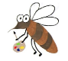

**Background information for parents and teachers**

Children will learn about the significance of prehistoric art and what this tells us about early humans. Children will explore how prehistoric people created paint using natural pigment. They will look at cave paintings and use these to inspire their own prehistoric art work. Children will create a textured surface to paint upon and explore charcoal, printing as well as using berries, spices and other natural materials to create their own paint. Children will also develop their **mixing of colours** to develop tints and shades to create a painting of Stonehenge.

|  |
| --- |
| Skills and techniques |
| * Line drawings and paintings using **charcoal**, **chalk** and **paint with fine brushes**. * Applying materials to create a **textured** canvas. * **Printing.** * Use a number of **brush techniques** to produce shapes, lines and washes. * **Mix** colours effectively. * Experiment with **creating mood with colour**. |

**Autumn**

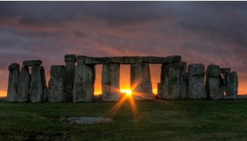

**Prior knowledge from Y2 used**

Children will have already explored the **appropriate size paint brush** to use when painting and how to create **horizontal** brush strokes. Children have created colour wheels and have mixed primary colours to make secondary colours.

**Y3 knowledge**

Children will be introduced to the **focal point** of their artwork which is the sunset, the use of **cool and warm colours** by creating tints and shades. Also to create the **circular element of the sunset** children will learn how to use a range of brush strokes effectively.

When creating cave art, the children will identify how stone age people gained **inspiration** from their surroundings and explore the use of **charcoal** to recreate art in the same style. Children will learn how to create a textured background

After producing their artwork children will peer assess as **art critics** using the appropriate artistic vocabulary.

Agreed outcome:

Stonehenge sunset art textured cave painting and a cave art collaborative print

