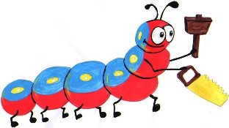

Lyng Primary School Knowledge Organiser

Design Technology

How could a Roman soldiers carry their possessions?

Summer

Year 3

Topic: DT

|  |  |
| --- | --- |
| What Goldilocks and Step On words will I use? | |
| **Spelling** | **Defintion** |
| **textiles** | Textiles are types of cloth or fabric, especially ones that have been woven. |
| **sew** | When you sew something such as clothes, you make them or repair them by joining pieces of cloth together by passing thread through them with a needle. |
| **stitch** | If you stitch cloth, you use a needle and thread to join two pieces together or to make a decoration. |
| **needle** | A needle is a small, very thin piece of polished metal which is used for sewing. It has a sharp point at one end and a hole in the other for a thread to go through. |
| **thread** | Thread or a thread is a long very thin piece of a material such as cotton, nylon, or silk, especially one that is used in sewing. |
| **seam** | A seam is a line of stitches which joins two pieces of cloth together. |
| **blanket stitch** | A strong reinforcing stitch for the edges of blankets and other thick material |



**Design Brief for pupils:**

* Review current purse designs
* Plan a purse to hold a Roman soldier’s salary
* Practise and evaluate stitches
* Evaluate our purse design

**Purpose:** To hold the earnings (salt) of a Roman soldier

**Audience:** Roman soldier



|  |
| --- |
| Skills and techniques |
| * Design with purpose by identifying opportunities to design. * Improve upon existing designs, giving reasons for choices. * Cut materials accurately and safely by selecting appropriate tools. * Measure and mark out to the nearest millimetre. * Select appropriate joining techniques. * Understand the need for a seam allowance. * Join textiles with appropriate stitching. * Select the most appropriate techniques to decorate textiles. |

**Year 3 - Textiles**



Spring Term - Textiles

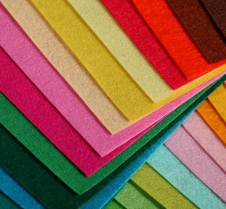

**Fabrics -** Different fabrics have different properties (characteristics) which make them good for different purposes. For example, some are soft and provide a cushion (e.g. felt) whilst others can be thin and lightweight (e.g. silk, cotton). This can make them easier to join/ decorate with.

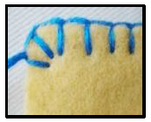

**Blanket Stitch -** Whilst this can be quite time-consuming, it creates an attractive seam and a secure join. Another way to reinforce the edges of thick materials. This stitch is popular as it is thought to be aesthetically-pleasing.

**Agreed outcome:** A purse for a Roman soldier