|  |  |  |
| --- | --- | --- |
| **Lyng Primary School P.E Knowledge Organiser** | | |
| **Topic: Hockey** | Year 3 | Autumn 2 |

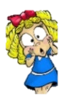



**Enquiry Questions**

* How do we hold the hockey stick?
* Can we keep control of the ball, when dribbling in and out of obstacles?
* How do we complete a push pass?
* Can you we dribble past an opponent and shoot?
* What is the correct technique when performing a block tackle?
* Can we transfer skills into a game situation?

|  |  |
| --- | --- |
| **Key words** | |
| **Spelling** | **Definition** |
| Grip | How players hold the hockey stick. |
| Dribble | When players dribble the ball in hockey, they are travelling with the ball showing close control. |
| Score | In a game of hockey, if a player scores a goal they gain a goal/point for their team. |
| Push pass | Push pass is a pass where the player places the stick onto the ball and pushes in the direction of a team mate to make a pass |
| Shoot | Shooting the ball at the goal, when trying to score for the team. |
| 1 v 1 | When in a game situation coming up against 1 other player from the other team. |

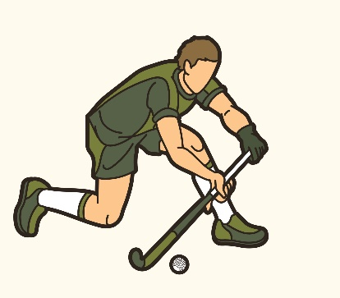 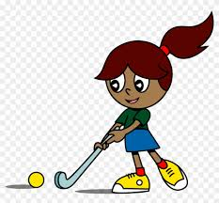

***“You miss 100% of the shots you don’t take”***

* **Wayne Gretzky**

**– Mav Levy**

|  |  |  |
| --- | --- | --- |
| **Lyng Primary School P.E Knowledge Organiser** | | |
| **Topic: Hockey** | Year 3 | Autumn 2 |

Learning Outcomes

* To know how to hold the hockey stick correctly.
* To develop close control when dribbling in and out of obstacles.
* To be able to make successful push passes.
* To combine dribbling and shooting together.

To develop different tackling techniques.

* To gain a basic understanding of the rules of hockey.

