|  |  |  |  |
| --- | --- | --- | --- |
| **F:\Learning bugs\Foundation Subjects\Dolly the Fly - Science.jpgLyng Primary School Knowledge Organiser** | | | |
| **Topic: Light and Shadow** | **Science**  **How does light effect shadows?** | Year 3 | Summer 1 |

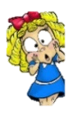

**Notable scientists**

**Thomas Edison**

He created the light bulb by 1879.

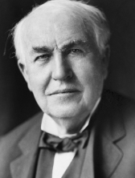

**What should I already know?**

* We need light to be able to see things.
* Darkness is when there is no light.
* Some materials reflect light.
* I can name some everyday light sources such as torches, lights and the sun.
* I understand that looking directly at bright lights can be harmful to my eyes and I must never look directly at a bright light including the sun.

|  |  |
| --- | --- |
| **What Step On and Goldilocks words will I use?** | |
| **Spelling** | **Definition** |
| Light source | Something that gives out light |
| luminous | A word used to describe a light source |
| reflection | When light bounces of a material’s surface |
| transparent | A material which lets light through so little or no shadow forms |
| translucent | A material which lets some light through so that a faint shadow forms |
| opaque | A material which lets no light through so a shadow forms |
| shadow | A dark area caused by something blocking the source of light. |

|  |
| --- |
| Investigate! |
| * Record findings using simple scientific language, drawings, labelled diagrams, bar charts and tables – measuring and recording the lengths of shadows. * Ask relevant questions – what makes a shadow longer or shorter? – let’s investigate! |

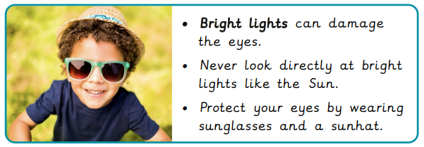

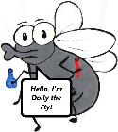

**What will I know by the end of the unit?**

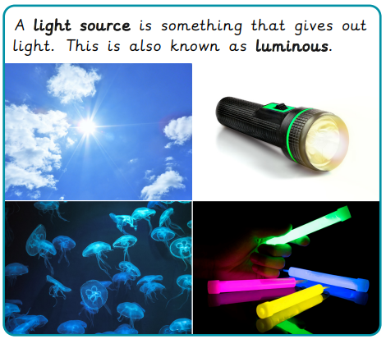

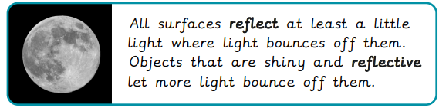

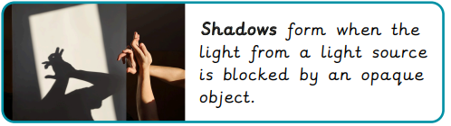

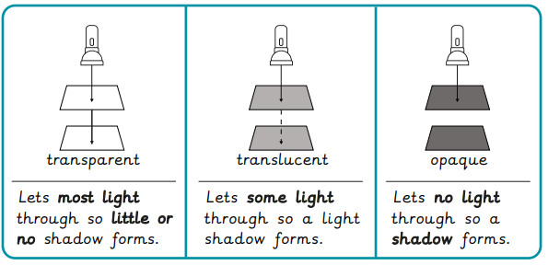

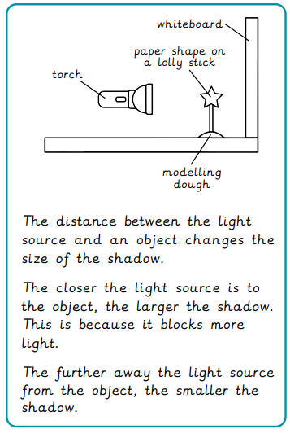

|  |
| --- |
| Our Enquiry Questions |
| * What are light sources and why are they important? * What is reflection? * Where do Shadows come from? * How do shadows change throughout the day? * Investigating shadows. How can we change the size of a shadow by moving the light source? * What makes a material suitable for a shadow puppet? |

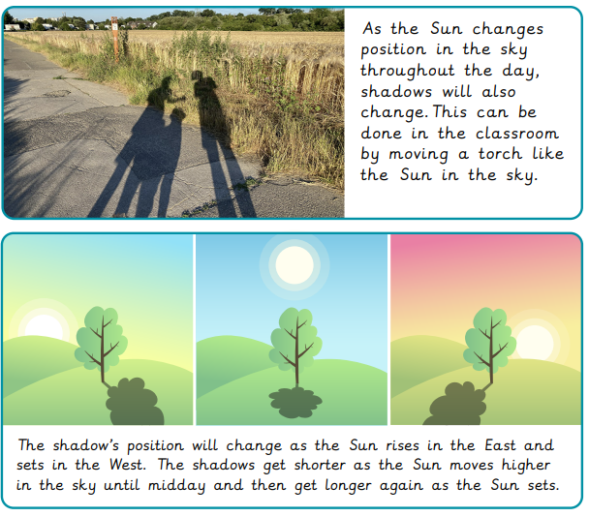



|  |  |  |  |
| --- | --- | --- | --- |
| **F:\Learning bugs\Foundation Subjects\Dolly the Fly - Science.jpgLyng Primary School Knowledge Organiser** | | | |
| ***Topic: Science*** | ***Science***  ***How does light effect shadows?*** | *Year 3* | *Spring 2* |

|  |  |  |  |
| --- | --- | --- | --- |
| A light source is something that gives out light. This is knows as | **S** | | **E** |
| a) shiny |  |  | |
| b) luminous |  |  | |
| c) reflective |  |  | |

|  |  |  |
| --- | --- | --- |
| Which word completes the sentence correctly:  The shadow gets___________ as the sun gets higher in the sky. | **S** | **C** |
| a) shorter |  |  |
| b) longer |  |  |
| c) lighter |  |  |
|  |  |  |

|  |  |  |
| --- | --- | --- |
| A material that lets most light through, so forms little shadow is known as: | **S** | **E** |
| 1. translucent |  |  |
| 1. opaque |  |  |
| 1. transparent |  |  |

|  |  |  |
| --- | --- | --- |
| If a light source is moved closer to an object what will happen to the shadow? | **S** | **E** |
| 1. it will get smaller |  |  |
| 1. it will get larger |  |  |
| 1. it will not change |  |  |

|  |  |  |
| --- | --- | --- |
| A material which lets no light through, so forms a shadow is known as: | **S** | **E** |
| 1. translucent |  |  |
| 1. opaque |  |  |
| 1. transparent |  |  |

|  |  |  |
| --- | --- | --- |
| Why do some ‘shiny’ objects appear to be luminous when they are not. | **S** | **E** |
| 1. because they reflect light |  |  |
| 1. because they are sparkly |  |  |
| 1. Because they are a light colour |  |  |

|  |  |  |
| --- | --- | --- |
| A material which lets some light through so that a faint shadow forms is known as: | **S** | **E** |
| 1. translucent |  |  |
| 1. opaque |  |  |
| 1. transparent |  |  |
| 1. all of the above |  |  |

|  |  |  |
| --- | --- | --- |
| Which of the following is not a source of light? | **S** | **E** |
| 1. the sun |  |  |
| 1. a diamond |  |  |
| 1. a glow stick |  |  |

Start of quiz _________________

End of quiz ________________