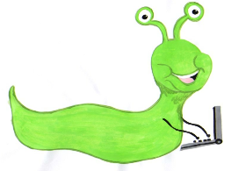

Lyng Primary School Knowledge Organiser

Information Technology



Spring 1

Drawing and publishing

Year 3

Topic: IT

|  |  |
| --- | --- |
| What Goldilocks and Step On words will I use? | |
| **Spelling** | **Defintion** |
| Text box | A section or object on a page that allows a user to enter text. |
| Format | The way in which text or pictures are set out. |
| Wrap text | A feature that shows all of the information in a cell, even if the cell overflows the cell boundary. |
| Aspect ratio | The ration of the width to the height of an image or screen. |
| Layout | The way in which text or pictures are set out on a page. |
| Font | Style of text on the screen. |
|  |  |
|  |  |
|  |  |

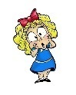

**Aims of this unit**

* Select, use and combine a variety of software on a range of digital devices to design and create a range of programs, systems and content that accomplish given goals, including collecting, analysing, evaluating and presenting data and information.
* Use technology purposefully to create, organise, store, manipulate and retrieve digital content.
* Demonstrating a variety of publishing skills such as:
* Draw with different shapes and lines.
* Order and group objects.
* Manipulate shapes and lines.
* Recognise an effective layout.
* Combine text and images.
* Lay out objects effectively

**Safeguarding**

Filtering and monitoring system is in place. Children will use their own log in details to track any misuse and to protect the child from harmful websites and pop ups. Children will be reminded of how to stay safe online and to use technology safely and respectfully and to tell a trusted adult if there is anything on their computer that makes them uncomfortable. When using the iPads, the monitoring software will track which iPad has been used to enable us to know which class has used the iPad.

|  |
| --- |
| Outcomes |
| **All children**   * Draw objects * Insert text boxes and images   **Most children**   * Order and group objects * Move, resize and arrange text boxes and images effectively.   **Some children**   * Manipulate objects. * Create a layout of objects with no unnecessary space using colour and font effectively. |

Spring Term 1

Drawing and publishing

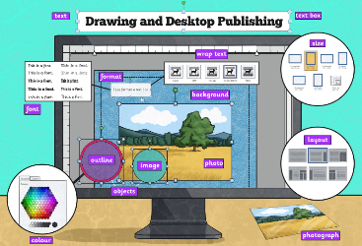

**In this unit…**

Children will develop their graphic and presentation skills by introducing drawing as opposed to painting. It also helps to further their children’s understanding of layouts using a desktop publishing application. Children will learn to draw, order, group and manipulate objects to make a picture.

**Agreed outcome:**

Children will create a Topic web poster linked to the Romans.