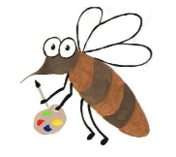

Lyng Primary School Knowledge Organiser

Art

Spring Term

Year 3

Topic: Art

**Background information for parents and teachers** Children will study Egyptian artwork and the style that was used as well as the **symbolism**. In Egyptian portraits the head of the character is always drawn from the side, while the body is seen from the front. This is frontalism. Children will use this style to create their own **self portrait** and Egyptian headdress. Children will craft and create their own Egyptian paper scroll.

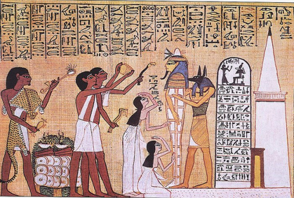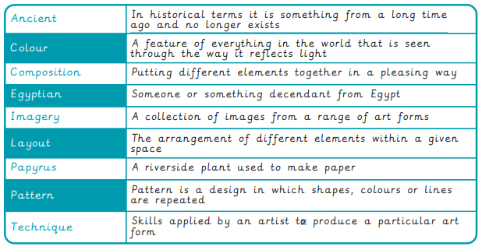

|  |
| --- |
| Skills and techniques |
| • **Replicate** some of the techniques used by  notable artists, artisans and designers.  • **Create original pieces** that are influenced by  studies of others  • **Select and arrange** materials for a striking  effect.  • **Ensure** work is precise.  • Use **coiling**, **overlapping**, **tessellation**, **mosaic**  and **montage**. |

**Spring**

**Egyptian Frontalism making papyrus**

**Egyptian Headdress Symbolism**

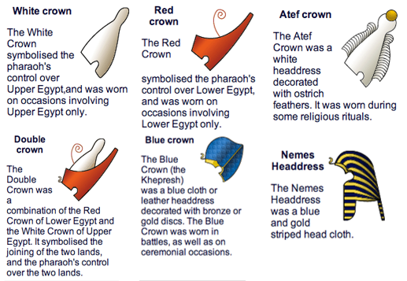

**Y3 knowledge**

Heads were almost always shown in **profile** (sideways) view. It is easier to get the nose correct when drawing a face from the side. Profile heads also allowed the artist to show the ear and headdresses or hair. Some headdresses were twisted to show the front view to make the image clearer.

Agreed outcome:

Paper scrolls

Pharaoh Self Portrait

