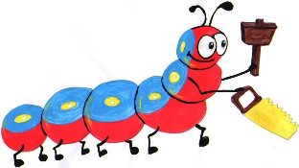

Lyng Primary School Knowledge Organiser

Design Technology

Year 3

Topic: DT

Autumn

|  |  |
| --- | --- |
| What Goldilocks and Step On words will I use? | |
| **Spelling** | **Defintion** |
| Join | to bring in contact, connect, or bring or put together |
| Design | to generate, develop and communicate ideas for a product. |
| Wood | the hard, fibrous substance composing most of the stem and branches of a tree or shrub, and lying beneath the bark |
| Forest | a large tract of land covered with trees and underbrush; woodland |
| Settlement | the act of making stable or putting on a permanent basis. |
| branches | a division or subdivision of the stem or axis of a tree, shrub, or other plant. |
| weaving | Interlacing matereials, such as branches, togethere to form a secure join. |



**Design Brief for pupils:**

* Create a shelter outside using stone age materials
* Choose suitable materials
* Ensure the shelter is big enough to house people

**Purpose:** To create a successful shelter using equipment and resources in a forest

**Audience:** The shelter will be used by stone age people looking to stay warm at night and safe from predators.



|  |
| --- |
| Skills and techniques |
| * Explore different types of shelters used and evaluate there effectiveness * Explore different joining techniques such as an ‘A’ frame and weaving. * Cut materials accurately and safely by selecting appropriate tools. * Select appropriate materials to build the shelter * Ensure all joins are safe and secure. |

Autumn Term

**Construction**

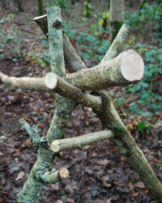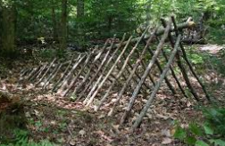

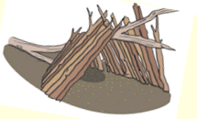

An ‘A’ frame shelter

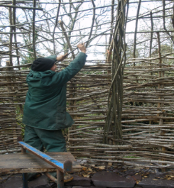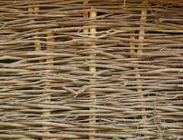

**Agreed outcome:**

A stone age shelter built from materials within

The forest school area.

Weaving technique