|  |  |  |  |
| --- | --- | --- | --- |
| **Lyng Primary School Knowledge Organiser** | | | |
| **Topic: Greece** | **Is Greece a good location to migrate?** | Year 3  Battles, beliefs and buildings | Spring 2 |

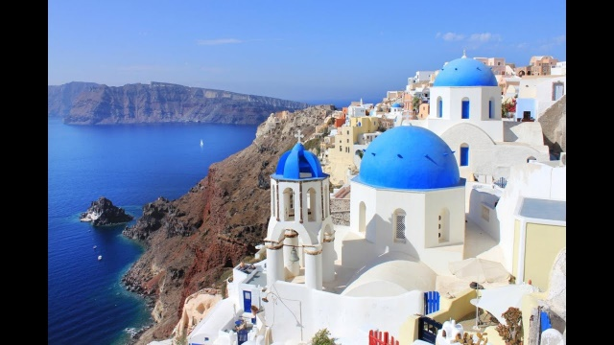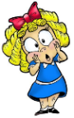

**Background information for parents and teachers**

Greece has a long and rich history, and a culture, which has developed over thousands of years from the time of the Ancient Greeks. Its warm climate also makes it a popular holiday destination for people from across the world.

|  |  |
| --- | --- |
| **What Step On and Goldilocks words will I use?** | |
| **Spelling** | **Definition** |
| Biome | A biome is a natural area of animals and plants. The world is divided into many different biomes and they all vary depending on their climate |
| Atlas | An atlas is a book of maps. |
| Deciduous biome | This is the biome that Europe is part of.. Many plants and trees shed their leaves yearly. |
| Euro | The euro is a unit of money that is used by the member countries of the European Union. |
| Europe | The second smallest continent. |
| Mediterranean | The Mediterranean refers to the southern part of Europe, which is next to the Mediterranean Sea. |
| mountainous | A mountainous place has many mountains. |
| Mt. Olympus | The highest mountain in Greece. |
| peninsula | A peninsula is a long narrow piece of land, which sticks out from a larger piece of land and is surrounded by water. |
| tourism | Tourism is the business of providing services for people on holiday, for example hotels, restaurants, and trips. |
| Physical feature | A naturally occurring feature of the world |
| Human Feature | A feature made by humans |

|  |
| --- |
| **Geographical study** |
| * Use maps, atlases, globes and digital/computer mapping to locate countries and describe features. * Name and locate the countries of Europe and identify their main physical and human characteristics. * Describe key aspects of:   • physical geography, including: rivers, mountains, volcanoes and earthquakes and the water cycle.  • human geography, including: settlements and land use. |

**Fieldwork Opportunities**

Orienteering fact finding about Greece

**Key Text**

Children’s atlas

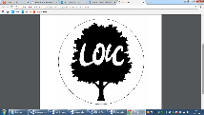

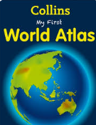

**Significant places**

* Greece

**Our Storytelling Approach to enhance engagement**

|  |  |  |
| --- | --- | --- |
| **People:**  The Greeks | **Place:**  City of Troy | **Problem:**  Queen of Sparta has been kidnapped |

**Information about Greece**

Our Enquiry Questions:

Which countries make up Europe?

What are the different types Physical features in Europe?

What are the physical and Human features of Greece?

How can we compare countries in Europe?

What is the deciduous biome in Europe?

How did the terrain in Greece shape early civilisations?

-Greece is a country in south-eastern Europe.

-It borders a number of countries, including Albania, Turkey, Bulgaria and Macedonia.

-It also has a large coastline on the Mediterranean Sea. There are thousands of islands around the Greek peninsula. These islands are really the tips of mountains that sunk beneath the sea long ago.

Greece has more than 15, 000 km of coastline & beaches.

- 80% of Greece is made up of mountains.

-About 10.8 million people live in Greece. The capital city is Athens.

-Greece has around 6,000 islands, although only around 227 of these are habited.

**Flag**

**Maps to be studied**

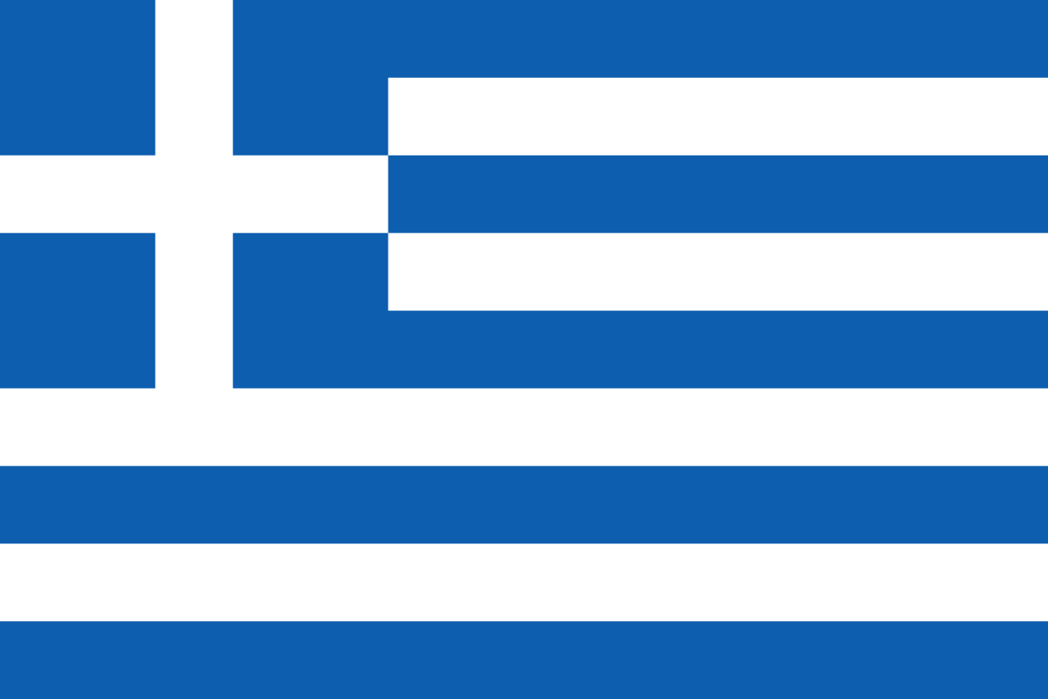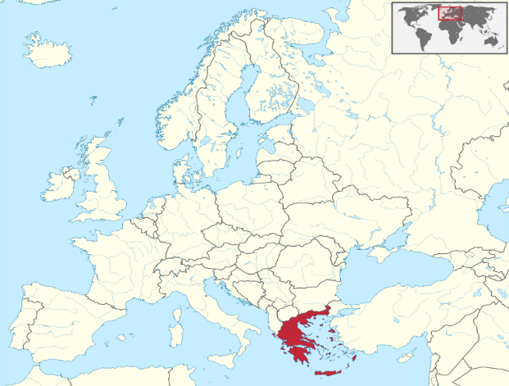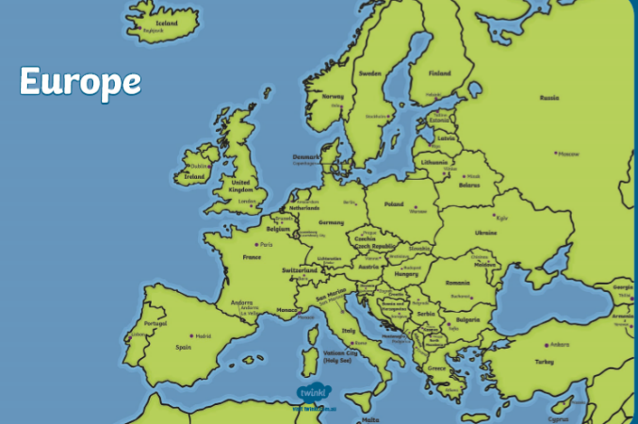

**Agreed Outcome**

A labelled map of Europe.

|  |  |  |  |
| --- | --- | --- | --- |
| **Lyng Primary School Knowledge Organiser** | | | |
| **Ancient Greece** | **Is Greece a good location to migrate?** | Year 3  Battles, beliefs and buildings | Spring 2 |

|  |  |  |
| --- | --- | --- |
| What is a peninsula? | **S** | **E** |
| a narrow piece of land which sticks out and is almost completely surrounded by water. |  |  |
| A tall piece of land. |  |  |
| Somewhere that has little water. |  |  |

|  |  |  |
| --- | --- | --- |
| Greece is made up of… | **S** | **E** |
| One island |  |  |
| Lots of tiny islands |  |  |
| Two islands |  |  |

|  |
| --- |
| Name the four points on a compass. |
| Start – |
| End - |

|  |
| --- |
| **My score** |
| Start - |
| End - |

|  |
| --- |
| Name three countries in Europe |
| Start - |
| End - |

|  |  |  |
| --- | --- | --- |
| What two colours are on the Greek flag? | **S** | **E** |
| Green and blue |  |  |
| Red and white |  |  |
| Blue and White |  |  |

|  |
| --- |
| Greece is made up of lots of islands |
| Start - True / False |
| End - True / False |

|  |  |  |
| --- | --- | --- |
| What is tourism? | **S** | **E** |
| The business of providing services for people on holiday, for example hotels and trips. |  |  |
| Buying expensive items to give people. |  |  |
| People moving from one place to live permanently in another. |  |  |