|  |  |  |
| --- | --- | --- |
| **Lyng Primary School P.E Knowledge Organiser** | | |
| **Topic: DANCE** | Year 3 | Spring 2 |





**Enquiry Questions**

* What is a dance routine?
* Can we copy, remember and perform a dance?
* Can you add your own moves to the dance routine from the previous week?
* What do we need to include to build our own dance routine?
* How can we apply cannon to our routine?
* Can we evaluate each other’s dance routine?

|  |  |
| --- | --- |
| **Key words** | |
| **Spelling** | **Definition** |
| Beats | Counting the beats of the song by using beats of 4 to stay with the rhythm of music. |
| Cannon | Is where individuals perform the same dance move at different times. |
| Rhythm | Applying dance moves that are linked and are able to flow |
| Routine | Perform a routine, is where a build-up moves are put together to create a sequence. |
| Step | Move feet with weight transfer. |

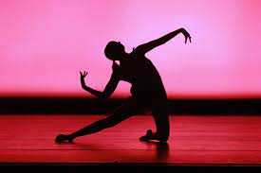

***“Dancers don’t need wings to fly”***

**– Mav Levy**

|  |  |  |
| --- | --- | --- |
| **Lyng Primary School P.E Knowledge Organiser** | | |
| **Topic: DANCE** | Year 3 | Spring 2 |

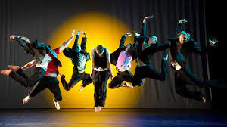

Learning Outcomes

* To be able to repeat steps shown.
* To be able to copy, remember and perform a dance.
* To be able to add dance moves with quality to a routine.
* To create our own dance routine.
* To understand how to apply cannon to a routine.
* To perform the routine to the rest of the class and to be able to analyse.