|  |  |  |  |
| --- | --- | --- | --- |
| **Lyng Primary School Knowledge Organiser** | | | |
| **Topic: Stone Age** | **How did early humans locate the best place to settle?** | Year 3  Battles, beliefs and buildings | Autumn 1 |

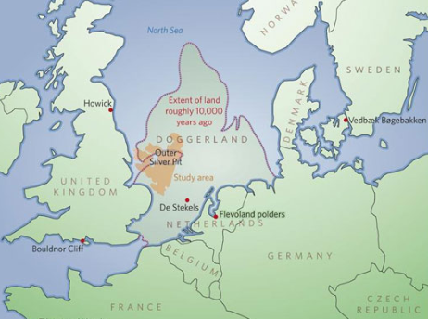

**Background information for parents and teachers**

Around 800,000 years ago Britain was joined to continental Europe by a land bridge allowing humans to move around the whole region.

Palaeolithic era - the climate in Britain changed several times with large areas of land covered with thick ice during the coldest periods known as the Ice Ages.

Mesolithic - This period of prehistory marked the end of the last Ice Age. Humans returned to Britain as the climate got warmer and followed a hunter gatherer life style.

|  |  |
| --- | --- |
| **What Step On and Goldilocks words will I use?** | |
| **Spelling** | **Definition** |
| border | The **border** between **two countries** or regions is the **dividing line between them**. |
| capital | The **capital** of a country is the **city or town** where its **government** or **parliament meets.** |
| compass | A **compass** is an instrument that you use for **finding directions**. |
| human geography | The branch of geography dealing with how **human activity** is influenced by the earth's surface |
| land use | The **function of the land** and what people decide to use it for. |
| location | A **location** is the **place** where something is **situated.** |
| peak | A **peak** is a mountain or the **top of a mountain**. |
| physical geography | The **branch of**[**geography**](https://www.collinsdictionary.com/dictionary/english/geography) that [deals](https://www.collinsdictionary.com/dictionary/english/deal) with the **natural**[**features**](https://www.collinsdictionary.com/dictionary/english/feature) of the earth's surface |
| plain | A **plain** is a **large flat area of land** with very few trees on it. |
| settlement | A **settlement** is a place where people have come to live and have built homes. |
| survey | **Study** or look at the **land carefully** |
| terrain | **Terrain** is used to refer to an area of land or a type of land when you are considering its **physical features.** |
| valley | A **valley** is a **low**[**stretch**](https://www.collinsdictionary.com/dictionary/english/stretch)**of land between**[**hills**](https://www.collinsdictionary.com/dictionary/english/hill)**,** [especially](https://www.collinsdictionary.com/dictionary/english/especially) one that has a river flowing through it. |

|  |
| --- |
| **Geographical study** |
| **Topography - physical geography**   * Looking at the topography of Britain. * Locating rivers, mountain and other natural features. * Looking at where people settled and why. * Look at how aspects of Britain have changed over time. |

**Fieldwork Opportunities**

* **Building a shelter in the most suitable location in forest school**
* **Map work on the field, using compass points**

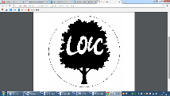

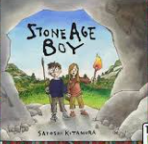

**Significant places**

* UK
* Mountains of the UK
* Rivers of the UK

**Our Storytelling Approach to enhance engagement**

|  |  |  |
| --- | --- | --- |
| **People:**  Early human | **Place:**  Left the caves | **Problem:**  A suitable location to build a shelter |

**UK maps to be studied**

**Key facts and locations**

**Enquiry Questions:**

**Labelled with mountains**

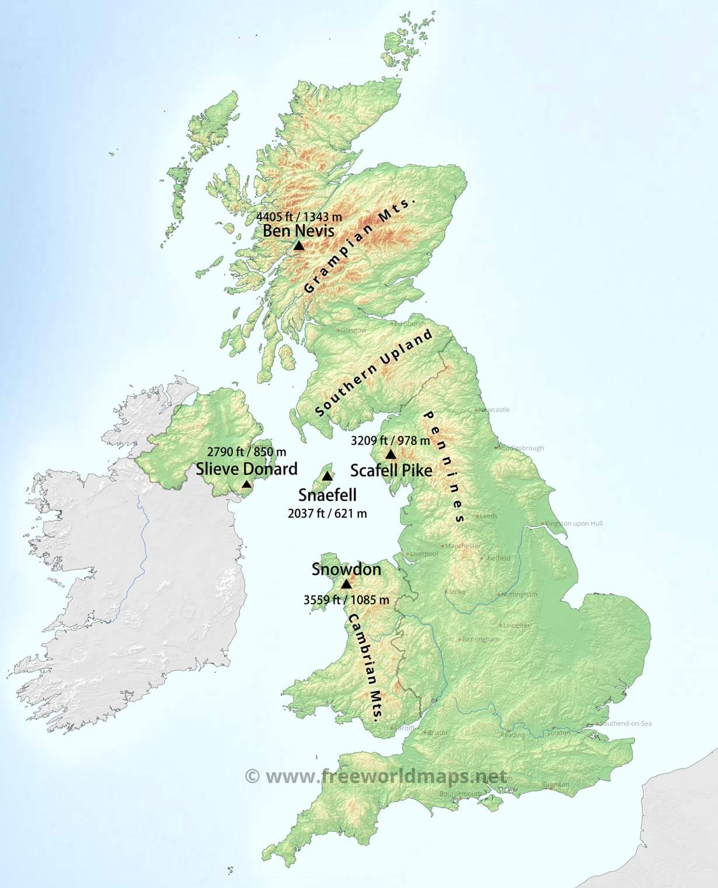

What makes a good location for a settlement?

Where are the rivers and seas of the UK?

What are the mountains and hills of the UK?

How can a compass help us?

What do you see on the way to school?

Why is a key important when reading a map?

Most of the Stone Age settlements occurred near rivers.

All rivers tend to follow the same pattern: as the flow from the source of the mouth, they start of narrow and end up wider; they start of straight and end up meandering.

Ben Nevis is the highest mountain in the British Isles.

Scafell Pike is the highest mountain in England at 978 m (3,209 ft). It is located in Lake District National Park, in Cumbria .

Snowdon is the highest mountain in Wales, at an altitude of 1,085 m (3,560 ft) above sea level.

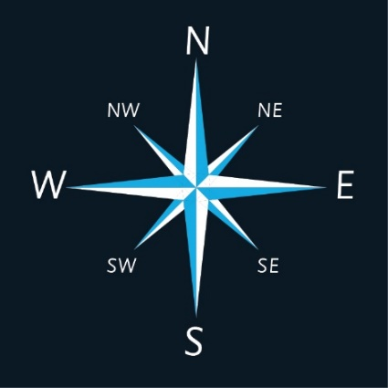

**8 compass points**

**Agreed Outcome**

A suitable location identified for a shelter and a shelter built there

|  |  |  |  |
| --- | --- | --- | --- |
| **Lyng Primary School Knowledge Organiser** | | | |
| **Topic:** | **Changes in Britain from the Stone Age to the Iron Age** | Year 3  Battles, beliefs and buildings | Autumn 1 |

|  |  |  |
| --- | --- | --- |
| 6. Which is the highest mountain in the UK? | **S** | **E** |
| 1. Snowdon |  |  |
| 1. Ben Nevis |  |  |
| 1. Skiddaw |  |  |

|  |
| --- |
| 8. A capital city is where the government or parliament meet. True or false? |
| S= E= |

|  |  |  |
| --- | --- | --- |
| 1. What does the word population mean? | **S** | **E** |
| 1. A variety of foods |  |  |
| 1. A group of countries |  |  |
| 1. All the people who live in it. |  |  |

|  |  |  |
| --- | --- | --- |
| 1. Which continent is Britain part of? | **S** | **E** |
| 1. Europe |  |  |
| 1. Asia |  |  |
| 1. North America |  |  |

|  |  |  |
| --- | --- | --- |
| 1. Which city is the capital of England? | **S** | **E** |
| 1. Birmingham |  |  |
| 1. London |  |  |
| 1. York |  |  |

|  |  |  |
| --- | --- | --- |
| 1. What is a peak? | **S** | **E** |
| 1. The top of a mountain |  |  |
| 1. The bottom of a river |  |  |
| 1. The start of a road |  |  |

|  |
| --- |
| 1. Name the four compass points. |
| S = E |

|  |  |  |
| --- | --- | --- |
| 1. What is a settlement? | **S** | **E** |
| 1. A place where people live |  |  |
| 1. A stone age tool |  |  |
| 1. A timeline of events |  |  |

|  |  |  |
| --- | --- | --- |
| 1. Which one of these is not a river in the UK? | **S** | **E** |
| 1. River Nile |  |  |
| 1. River Severn |  |  |
| 1. River Thames |  |  |