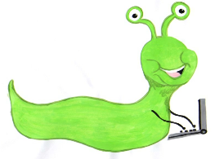

Lyng Primary School Knowledge Organiser

Information Technology



Autumn 1

Logo

Year 3

Topic: IT

|  |  |
| --- | --- |
| What Goldilocks and Step On words will I use? | |
| **Spelling** | **Defintion** |
| Algorithm | A set of instructions that will reach a desired outcome. |
| Logo | A text-based coding language used to control an on-screen turtle to create a pattern. |
| BK | Move backwards a distance of units. |
| FD | Move forward a distance of units. |
| RT | Turn right a number of degrees. |
| LT | Turn left a given number of degrees. |
| Repeat | Repeat a set of instructions a specified number of times. |
| Code block | A group of commands that are joined together and are run when a specific condition is met or when an event occurs |
| PU/PD | Lift the pen up or down on the screen. |



**Aims of this unit**

* Design, write and debug programs that accomplish specific goals, including controlling or simulating physical systems.
* Solve problems by decomposing them into smaller parts.
* Use sequence, selection and repetition in programs
* Work with variables and various forms of input and output.
* Use logical reasoning to explain how some simple algorithms work and to detect and correct errors in algorithms and programs.
* Create and debug an algorithm
* Using the move, rotate and repeat commands
* Draw regular polygons
* Using pen up and pen down
* Draw shapes
* Draw regular polygons and patterns

**Safeguarding**

Filtering and monitoring system is in place. Children will use their own log in details to track any misuse and to protect the child from harmful websites and pop ups. Children will be reminded of how to stay safe online and to use technology safely and respectfully and to tell a trusted adult if there is anything on their computer that makes them uncomfortable. When using the iPads, the monitoring software will track which iPad has been used to enable us to know which class has used the iPad.

|  |
| --- |
| Outcomes |
| **All children**   * Create and debug algorithms to draw regular polygons using the repeat command/block   **Most children**   * Draw shapes with spaces between using penup and pendown * Change and alter pen settings (Scratch)   **Some children**   * Draw regula polygons using Logo to calculate the angle (Turtle Logo) * Create and debug algorithms to draw patterns by repeating regular polygons (Scratch) |

Autumn Term

Programming Turtle Logo and Scratch

**In this unit…**

Turtle Logo will be used to teach children how to move and draw using the turtle

on screen, and then further develop algorithms using the ‘repeat’ command.

These skills will then be transferred to teaching children how to use blocks in

Scratch.

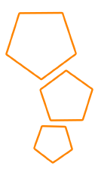

**Agreed outcome:**

To create and debug algorithms to draw patterns using Turtle Logo.