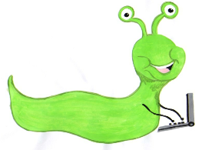

Lyng Primary School Knowledge Organiser

Computing

Topic: Computing



Scratch animated scene

Year 6

|  |  |
| --- | --- |
| What Goldilocks and Step On words will I use? | |
| **Spelling** | **Defintion** |
| Algorithm | A precise set of instructions that will reach a desired outcome. |
| Code | A set of rules or instructions. It is made up of words and numbers and when in the correct order, it will tell the computer program what you want it to do. |
| Sprite | The name given to a character in your project |
| Backdrop | The selected or designed background for your project. |
| Iteration | Repeating steps or instructions over and over. This is often called ‘loop.’ |
| Broadcast | Coding which send a message allowing the Sprite to have a speech bubble on the screen. |
| Visible/  invisible | Allows a sprite to be shown or hidden until required. |
| Transition | Allows the backdrop to be changed and gives options on what the change should look like |
| Audio | Sounds which can be added to a project. |
| Interaction | Using Broadcast/Receive blocks or If Then, Sprites can be trigged to allow a project to have interactive commands. |



**Aims of this unit**

* Design, write and debug programs that accomplish specific goals, including controlling or simulating physical systems.
* Solve problems by decomposing them into smaller parts.
* Use sequence, selection and repetition in programs; work with variables and various forms of input and output.
* Use logical reasoning to explain how some simple algorithms work and to detect and correct errors in algorithms and programs.
* Use Scratch to create and debug:
* An animated scene
* To broadcast a message
* To show and hide characters
* To Sequence a story
* To add audio and make interactive

**Safeguarding**

Filtering and monitoring system is in place. Children will use their own log in details to track any misuse and to protect the child from harmful websites and pop ups. Children will be reminded of how to stay safe online and to use technology safely and respectfully and to tell a trusted adult if there is anything on their computer that makes them uncomfortable. When using the iPads, the monitoring software will track which iPad has been used to enable us to know which class has used the iPad.

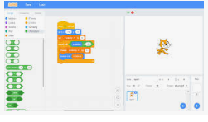

Autumn Term

Code using Scratch

**In this unit…**

Children will continue to develop their skills in writing their own algorithms. Building to create a short animated story.

**Agreed outcome**

Create an animated story linked to their topic work.

|  |
| --- |
| Outcomes |
| **All children**   * Select appropriate characters to match a scene * Animate characters with movement and speech. * Use show and hide blocks correctly in code. * Use broadcast and receive blocks correctly in code * Move and edit blocks as part of an algorithm   **Most children**   * Create a sequence of story scenes with added audio * Structure and sequence the animation of characters * Use the repeat command * Make a character visible or invisible   **Some children**   * Use rapid costume change to give animation effects * Add interactive features * Program the use of a single button to control background. * Control smooth transitions between characters, scene and audio |